EXPERIMENT 2 - 8 QUEEN PROBLEM

AIM
To develop a Python program to solve the 8-Queen Problem using the Backtracking algorithm.

OBJECTIVE
To prove that the Backtracking algorithm can place eight queens on a chessboard such that no two queens attack each other.

ALGORITHM
- Start from the first row and place a queen in a safe column.
- Check whether the queen conflicts with any previously placed queen.
- If the position is safe, place the queen and move to the next row.
- If no safe position exists, backtrack to the previous row and try another column.
- Repeat until all eight queens are placed successfully and display the solution.

SAMPLE CODE
N = 8

def print_solution(board):
for i in range(N):
for j in range(N):
print(board[i][j], end=" ")
print()

def is_safe(board, row, col):
# Check left side
for i in range(col):
if board[row][i] == 1:
return False

# Check upper diagonal
i, j = row, col
while i >= 0 and j >= 0:
if board[i][j] == 1:
return False
i -= 1
j -= 1

# Check lower diagonal
i, j = row, col
while i < N and j >= 0:
if board[i][j] == 1:
return False
i += 1
j -= 1

return True

def solve_queen(board, col):
if col >= N:
return True

for i in range(N):
if is_safe(board, i, col):
board[i][col] = 1

if solve_queen(board, col + 1):
return True

board[i][col] = 0 # Backtrack

return False

def solve():
board = [[0 for _ in range(N)] for _ in range(N)]

if not solve_queen(board, 0):
print("Solution does not exist")
return

print("Solution:")
print_solution(board)

solve()

FLOW CHART
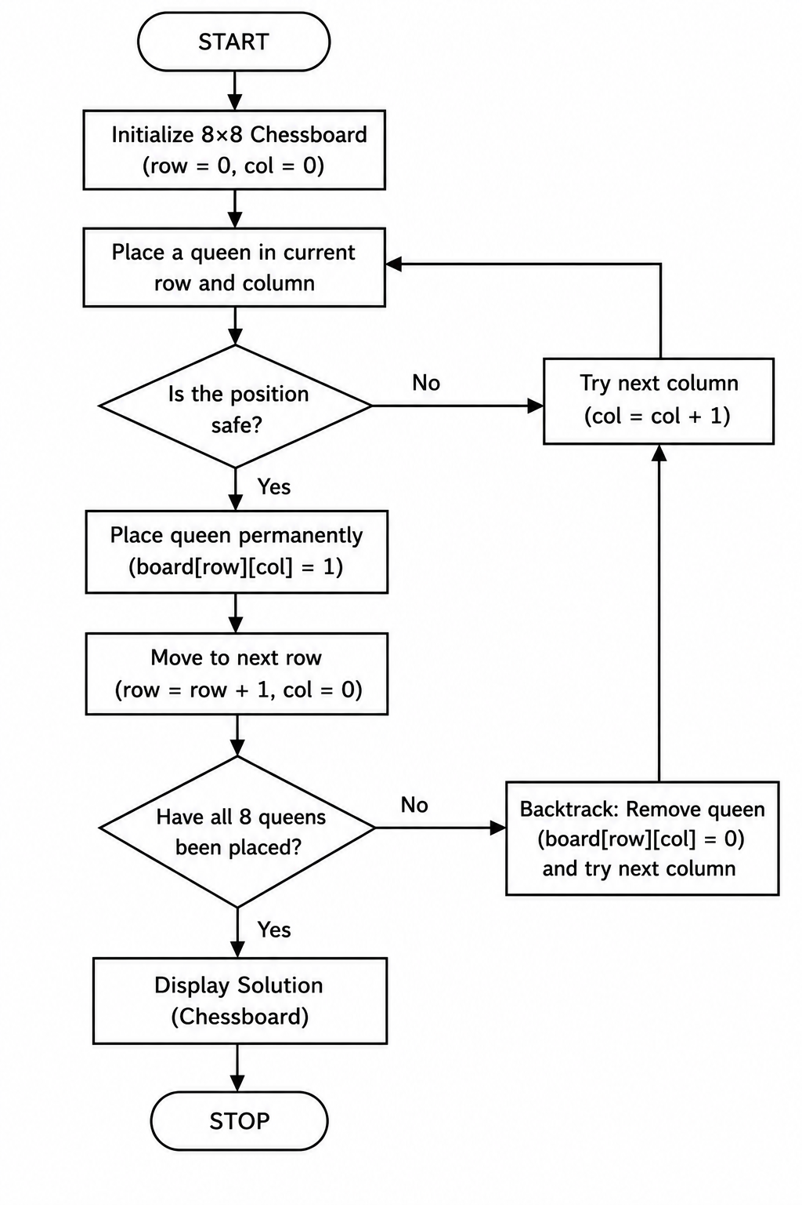
OUTPUT

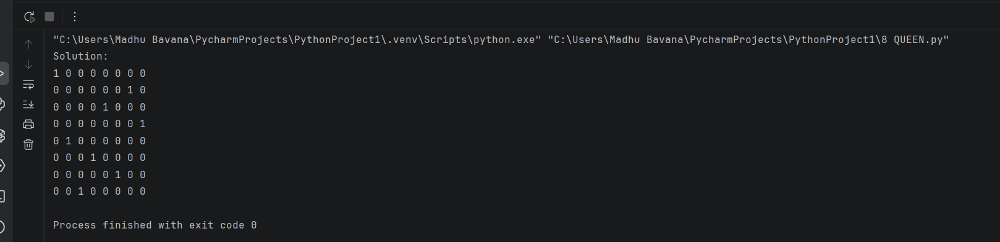

RESULT
The Python program was executed successfully. The Backtracking algorithm placed all eight queens on the chessboard without any two queens attacking each other, thereby obtaining a valid solution.

